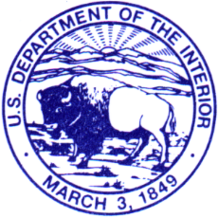
United States Department of the Interior

U. S. GEOLOGICAL SURVEY
OREGON WATER sCIeNCE CENTER
2130 SW Fifth Avenue
Portland, Oregon 97201

March 7, 2017

Mr. Ronald Twiner, Operations Manager
US Army Corps of Engineers
The Dalles Lock and Dam
PO Box 564
The Dalles, OR 97058

Dear Mr. Ronald Twiner:

This letter is provided to request access to The Dalles Dam for water-quality data collection operations. The USGS Oregon Water Science Center has collected total-dissolved-gas data at The Dalles Lock and Dam since 1998. We are under contract with the US Army Corps of Engineers Portland District to collect the same data in 2017. The area we need access to is the northeast corner of the upper deck of the powerhouse. We do not require access inside the powerhouse.

We would like obtain access to the project beginning March 14, 2017, so that we can install our monitoring equipment prior to the beginning of spill operations on April 1, 2017. Maintenance visits are scheduled every three weeks after March 14, but sometimes there is a need to visit the site outside of that schedule to address equipment malfunctions. We usually end our monitoring operations mid-September but request access through September 29, 2017, to allow time to remove our equipment after the spill season ends.

Please let me know if you have any questions about our schedule or operations.

Sincerely,

Nora Berggren Herrera
Project Manager/Hydrologist
nherrera@usgs.gov
503-251-3209

Enclosure
cc: Jane M. Dalgliesh, CRC, USACE
Jeffrey W. Randall, TDDRC, USACE

